# [WSl Installation:](https://learn.microsoft.com/en-us/windows/wsl/install)

(<https://learn.microsoft.com/en-us/windows/wsl/install>)

Developers can access the power of both Windows and Linux at the same time on a Windows machine. The Windows Subsystem for Linux (WSL) lets developers install a Linux distribution (such as Ubuntu, OpenSUSE, Kali, Debian, Arch Linux, etc) and use Linux applications, utilities, and Bash command-line tools directly on Windows, unmodified, without the overhead of a traditional virtual machine or dual boot setup.

### Install WSL Command

*wsl –install*

This command will enable the features necessary to run WSL and install the Ubuntu distribution of Linux. (This default distribution can be changed).

**\*\*** The above command only works if WSL is not installed at all.

** Please try running `*wsl --list –online*` to see a list of available distros and run `*wsl --install -d <DistroName>*` to install a distro.

Checking list of available distributions

Install other distributions.

## Change the default Linux distribution installed.

By default, the installed Linux distribution will be Ubuntu. This can be changed using the *-d* flag.

* To change the distribution installed, enter: wsl --install -d <Distribution Name>. Replace <Distribution Name> with the name of the distribution you would like to install.
* To see a list of available Linux distributions available for download through the online store, enter: wsl --list --online or wsl -l -o.
* To install additional Linux distributions after the initial install, you may also use the command: wsl --install -d <Distribution Name>.

Once you have installed WSL, you will need to create a user account and password for your newly installed Linux distribution. See the [Best practices for setting up a WSL development environment](https://learn.microsoft.com/en-us/windows/wsl/setup/environment#set-up-your-linux-username-and-password) guide to learn more.

## Check which version of WSL you are running.

**Checking Install WSL Version:**

**wsl -v -l**

**You can list your installed Linux distributions and check the version of WSL each is set to by entering the command: wsl -l -v in PowerShell or Windows Command Prompt.**

**wsl -l -v**

It will give you list of all install distribution, version and running status. Here In my case I have installed *two distribution which is* ***Ubuntu*** *and* ***Ubuntu-22.04*** and default distribution is ***Ubuntu.***

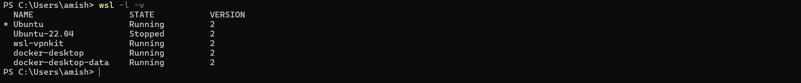

To set the default version to WSL 1 or WSL 2 when a new Linux distribution is installed, use the command: wsl --set-default-version <Version#>, replacing <Version#> with either 1 or 2.

**To set the default Linux distribution used with the wsl command, enter: wsl -s <DistributionName> or wsl --set-default <DistributionName>, replacing <DistributionName> with the name of the Linux distribution you would like to use. For example, from PowerShell/CMD, enter: wsl -s Debian to set the default distribution to Debian.**

To Set Defaults distribution: *from* ***Ubuntu*** *to* ***Ubuntu-22.04***

wsl -s Ubuntu-22.04

Before executing the command check the list of install distribution in wsl. By entering in PowerShell/CMD: wsl -l -v

Initial It default distribution was set to Ubuntu. After running the command *wsl -d Ubuntu-22.04* in terminal default distribution will be changed from ***Ubuntu*** to ***Ubuntu-22.04***

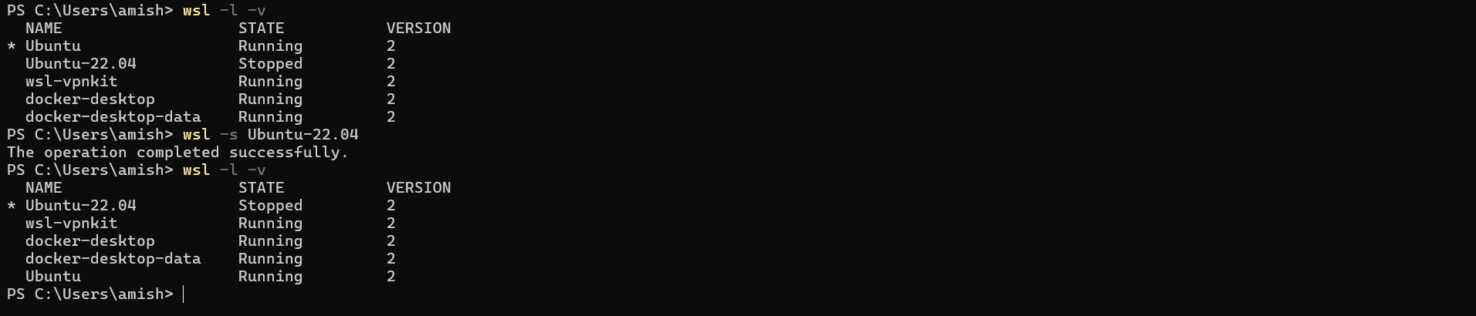

Change distribution from ubuntu to Ubuntu-22.04

After

Before

To run a specific wsl distribution from within PowerShell or Windows Command Prompt without changing your default distribution, use the command: wsl -d <DistributionName>, replacing <DistributionName> with the name of the distribution you want to use.

### Run a specific Distribution:

State Before running a distribution.

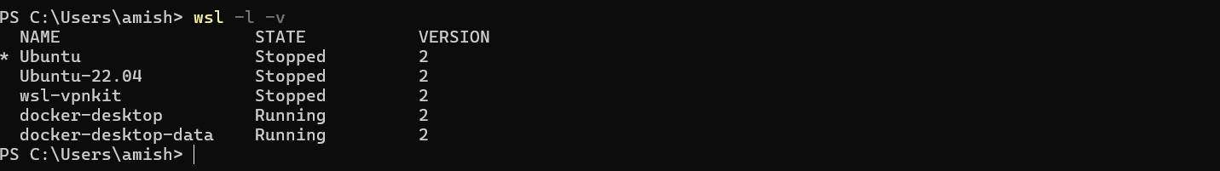

Installed Distribution but both are stopped state.

Running a distribution

wsl -d Ubuntu-22.04

State after running a distribution.

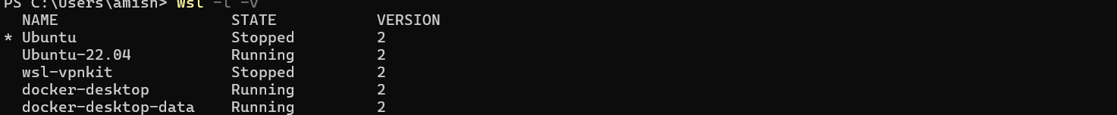

Installed Distribution but only selected is running.